# SOF For Employment

# 

I _____C Roopa_____________ [Candidate Name] Resident of __Door#896, Srivari Nilayam, 5th main , marathahalli, bangalore, 560037________________________. [Address], born on ____12/01/1994___ hereby declare my previous employment(s) for the periods outlined below;

# Employment Summary

|  |  |  |  |  |
| --- | --- | --- | --- | --- |
| **S.No.** | **Employer Name** | **From (MM/YY)** | **To (MM/YY)** | **Form 16 (Given/ Not Given)** |
| **1** | **Mphasis** | **15-july-2016** | **25-jan-2019** | **Not given** |
| **2** | **First Source** | **03-April-2019** | **27-Dec-2019** | **Not given** |
| **3** |  |  |  |  |
| **4** |  |  |  |  |
| **5** |  |  |  |  |
| **6** |  |  |  |  |
| **7** |  |  |  |  |
| **8** |  |  |  |  |
| **9** |  |  |  |  |

*I solemnly state that details & documents provided are true and correct to the best of my knowledge. I understand that if the said information is found inconsistent/ incorrect, will lead to appropriate actions including withdrawal of offer of employment per the recommendation given by the background verification team & in line with HCL policies.*

*I also understand that clearance of Background Verification (BGV) is one of the criteria for Onboarding in HCL / Employment principles in HCL.*

**Signature:** 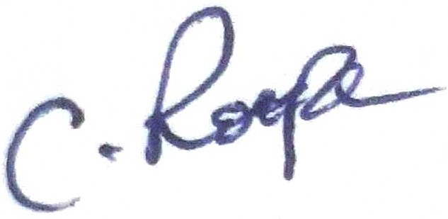

**Place : Bangalore**

**Date:** 10-08-2022

# 

# HCL Candidate: Additional Statement of Fact (wherein Form16 is not submitted)

**Employer Name Mphasis and First Source**

**Period of employment from (MM/YYYY) _July/2016_____ to (MM/YYYY)** _Jan/2019______and April/2019 to Dec/2019.

**Kindly state reason for non- submission of Form 16.**

**Employment Documents Remarks (Update reason for not sharing)**

Form 16 Not Received from Employer ________ _____________

Additional List of document shared to establish employment relationship, (If shared, click on the check box)

**Employment Documents Remarks (Update reason if not available)**

* Relieving letter ☑ __________________________________________
* Experience letter ☑ ___________________________________________
* Resignation acceptance letter ☑ ___________________________________________
* PF statement ☐ ___________________________________________
* Appraisal letter ☑ ___________________________________________
* Offer letter ☑ __________________________________________
* Mail from company domain ☐ ___________________________________________

*I confirm that all the information shared above are true, I hereby submit this statement of fact (SOF) for Employment to the above organization as per HCL requirement. I undertake and agree that commencement of my employment and its continuity is done basis my declaration and documents provided.*

*I also agree, HCL shall reserve all rights to terminate my employment forthwith and I shall bring no claim against HCL in any court of law or before any Governmental authority against termination of my employment on grounds of adverse finding of the Background verification done by HCL authorized vendor on the above facts.*

**Signed by:** 

**Dated:** 10-08-2022